Amazon AMIs

Amazon Machine Image

Case Study

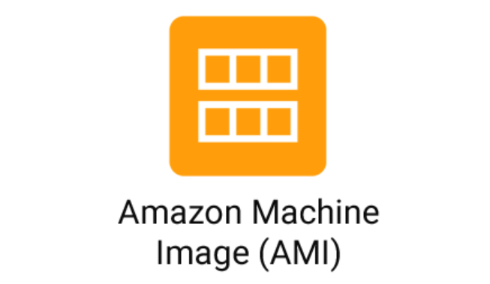

Introduction

An Amazon Machine Image (AMI) is a supported and maintained image provided by AWS that provides the information required to launch an instance. You must specify an AMI when you launch an instance. You can launch multiple instances from a single AMI when you require multiple instances with the same configuration. You can use different AMIs to launch instances when you require instances with different configurations.

An AMI includes the following:

* One or more Amazon Elastic Block Store (Amazon EBS) snapshots, or, for instance-store-backed AMIs, a template for the root volume of the instance (for example, an operating system, an application server, and applications).
* Launch permissions that control which AWS accounts can use the AMI to launch instances.
* A block device mapping that specifies the volumes to attach to the instance when it's launched.

There are two ways to use or create an AMI. By creating it or By Use an AMI

**1.** **Use an AMI**


    The AMI lifecycle (create, register, launch, copy, deregister).
   

AMI, you can use it to launch new instances and multiple that within same or different regions.

When you no longer require an AMI, you can deregister it.

**2.** **Create your own AMI**

You can launch an instance from an existing AMI, customize the instance (for example, [install software](https://docs.aws.amazon.com/AWSEC2/latest/UserGuide/install-software.html) on the instance), and then save this updated configuration as a custom AMI. Instances launched from this new custom AMI include the customizations that you made when you created the AMI.

The root storage device of the instance determines the process you follow to create an AMI. The root volume of an instance is either an Amazon Elastic Block Store (Amazon EBS) volume or an instance store volume. For more information about the root device volume, see [Amazon EC2 instance root device volume](https://docs.aws.amazon.com/AWSEC2/latest/UserGuide/RootDeviceStorage.html).

* To create an Amazon EBS-backed AMI.
* To create an instance store-backed AMI.

**3.** **Buy, Share and Sell AMIs**

After you create an AMI, you can keep it private so that only you can use it, or you can share it with a specified list of AWS accounts. You can also make your custom AMI public so that the community can use it. Building a safe, secure, usable AMI for public consumption is a fairly straightforward process.

**4.** **Deregister your AMI**

You can deregister an AMI when you have finished with it. After you deregister an AMI, it can't be used to launch new instances. Existing instances launched from the AMI are not affected.

Search or AMI in search bar you will get service suggestions like EC2 Image Builder.

But if you scroll down, you will get one Name AMIs in features.

You can click on it and open it.

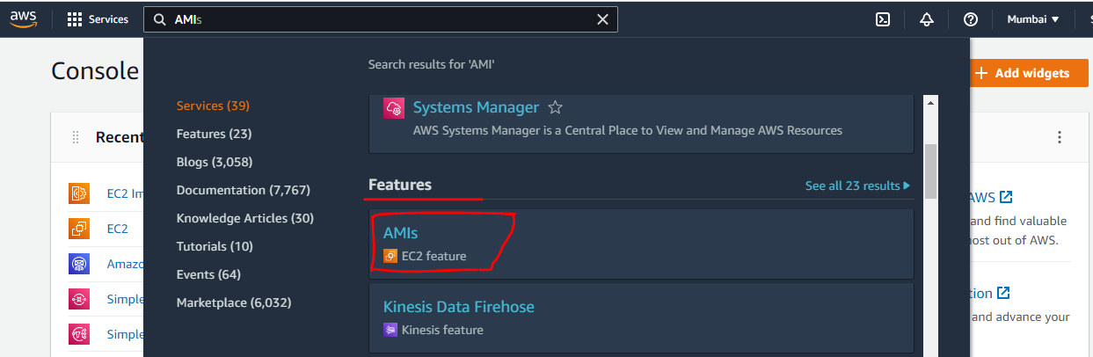

This is a dashboard of Amazon Machine Images will show you all the Images present on it.

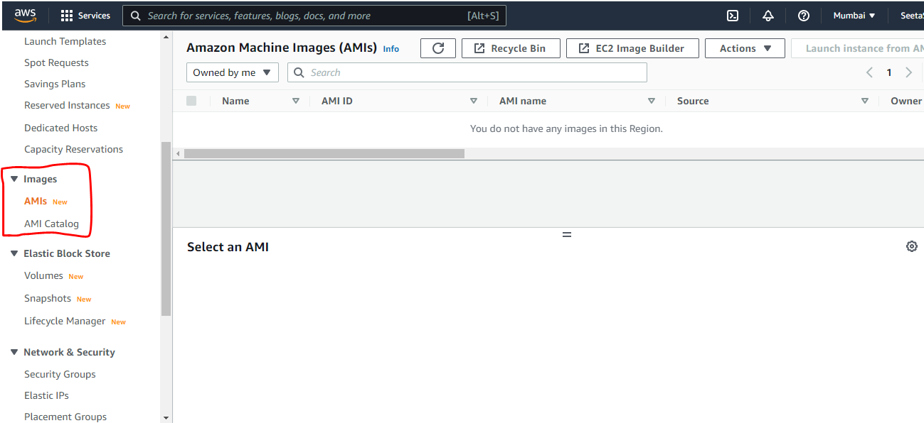

You can see in Images name list is empty and

One more option is there is to EC2 Image Builder that we saw previously while searching for AMIs.

Click on it.

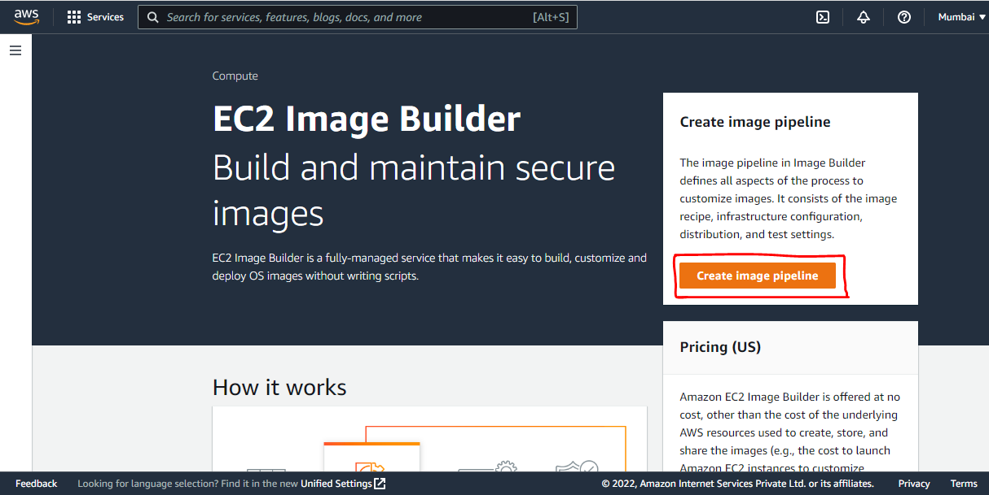

Specify pipeline details

Pipeline name

Description of pipeline

You can schedule your pipeline to run on per hour of day or day of hour, and frequency of day, week, or month.

If you want to add tags you can add it.

And click on next button.

After that you need to select the recipe

Two options are there

* Use existing recipe
* Create new one

Since we don’t have any existing recipe of image

We need to create a new recipe for it.

Select Image type either from Amazon Machine Image(AMI) or Docker image.

Please fill and enter the details of this configuration.

Like name

Description

And Version you can also written.

Select image

Three option are there one is

Select managed images

Enter custom AMI ID

Import base image from your local machine Virtual Machine.

Click on latest available OS version.

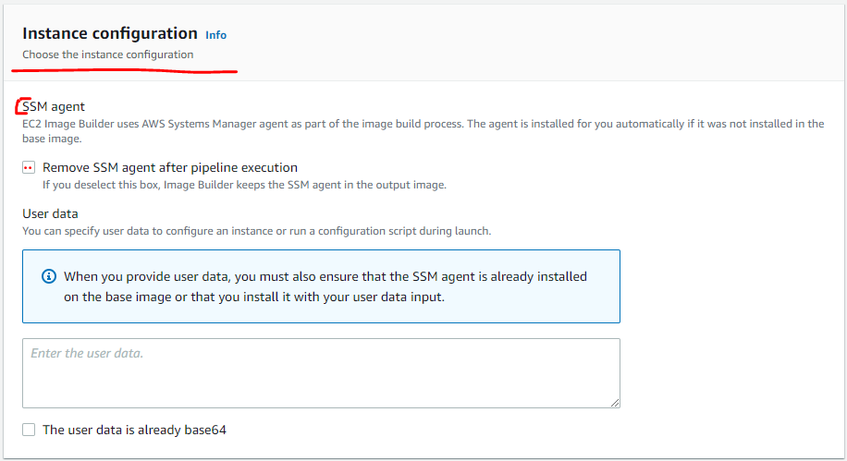

Write the working directory path.

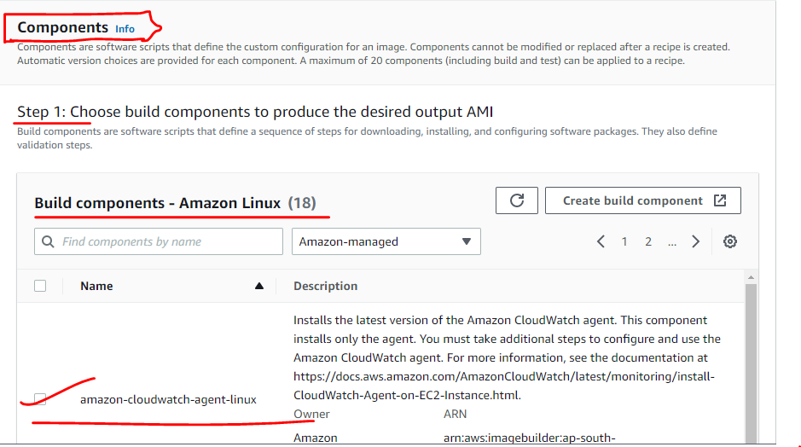

But you don’t want to create then we just have AMI Catalog

Just Click on Images inside that AMI Catalog.

Inside that AMIs we have –

QuickStart AMI – Commonly Used AMIs

My AMIs – Created by Me

AWS Marketplace AMI – AWS & trusted third party AMI

Community AMIs – Published by anyone.

